**The Story of Thomas Adams, gentleman**, *and his family and genealogy………………….*

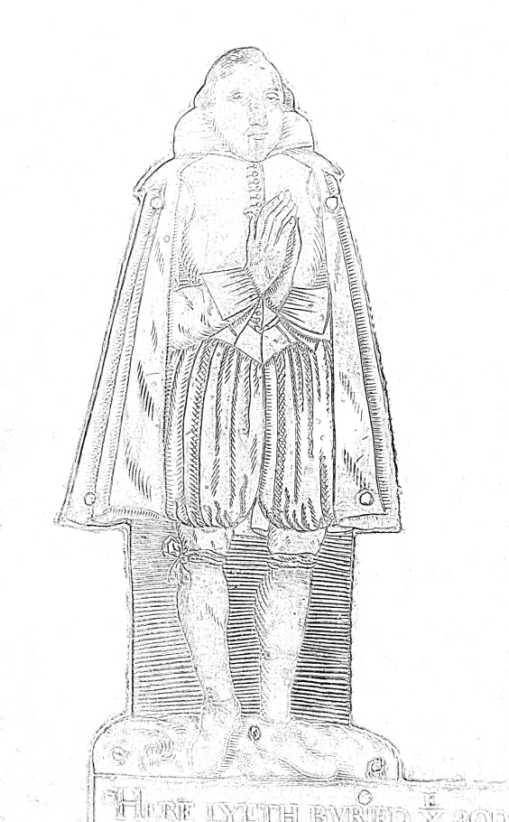

-***Overlord of the Manor of Swanbourne, Bucks***

***-Respected land owner***

***-London businessman***

***- Father of four***

[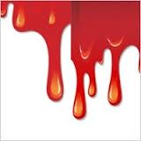](http://www.google.co.uk/imgres?q=dripping+blood+font&start=179&um=1&hl=en&sa=N&biw=1229&bih=932&tbm=isch&tbnid=8n7r5hAAoeOpeM:&imgrefurl=http://all-free-download.com/free-vector/blood-drip-vector-art.html&docid=Y7lUZM_Wi-Jy6M&imgurl=http://images.all-free-download.com/images/graphicmedium/vector_blood_159745.jpg&w=200&h=200&ei=i1czUZm1JceX1AXxioCYDg&zoom=1&ved=1t:3588,r:96,s:100,i:292&iact=rc&dur=2852&sig=118017228721647342227&page=7&tbnh=160&tbnw=155&ndsp=34&tx=77&ty=88)[](http://www.google.co.uk/imgres?q=dripping+blood+font&start=463&um=1&hl=en&sa=N&biw=1229&bih=932&tbm=isch&tbnid=-EIcsIcV29i5PM:&imgrefurl=http://lesniakchiropractic.com/images/blood-spatter-graphics&docid=GCnqBEwF9KxLhM&imgurl=http://i277.photobucket.com/albums/kk64/789fdsa789fdsa/blood_splatter_donor.gif&w=285&h=365&ei=B1gzUdzFKKOA0AWD8YGoCg&zoom=1&ved=1t:3588,r:82,s:400,i:250&iact=rc&dur=520&sig=118017228721647342227&page=16&tbnh=181&tbnw=156&ndsp=32&tx=74&ty=100)[](http://www.google.co.uk/imgres?q=dripping+blood+font&start=179&um=1&hl=en&sa=N&biw=1229&bih=932&tbm=isch&tbnid=8n7r5hAAoeOpeM:&imgrefurl=http://all-free-download.com/free-vector/blood-drip-vector-art.html&docid=Y7lUZM_Wi-Jy6M&imgurl=http://images.all-free-download.com/images/graphicmedium/vector_blood_159745.jpg&w=200&h=200&ei=i1czUZm1JceX1AXxioCYDg&zoom=1&ved=1t:3588,r:96,s:100,i:292&iact=rc&dur=2852&sig=118017228721647342227&page=7&tbnh=160&tbnw=155&ndsp=34&tx=77&ty=88)[](http://www.google.co.uk/imgres?q=dripping+blood+font&start=463&um=1&hl=en&sa=N&biw=1229&bih=932&tbm=isch&tbnid=-EIcsIcV29i5PM:&imgrefurl=http://lesniakchiropractic.com/images/blood-spatter-graphics&docid=GCnqBEwF9KxLhM&imgurl=http://i277.photobucket.com/albums/kk64/789fdsa789fdsa/blood_splatter_donor.gif&w=285&h=365&ei=B1gzUdzFKKOA0AWD8YGoCg&zoom=1&ved=1t:3588,r:82,s:400,i:250&iact=rc&dur=520&sig=118017228721647342227&page=16&tbnh=181&tbnw=156&ndsp=32&tx=74&ty=100)[](http://www.google.co.uk/imgres?q=dripping+blood+font&start=179&um=1&hl=en&sa=N&biw=1229&bih=932&tbm=isch&tbnid=8n7r5hAAoeOpeM:&imgrefurl=http://all-free-download.com/free-vector/blood-drip-vector-art.html&docid=Y7lUZM_Wi-Jy6M&imgurl=http://images.all-free-download.com/images/graphicmedium/vector_blood_159745.jpg&w=200&h=200&ei=i1czUZm1JceX1AXxioCYDg&zoom=1&ved=1t:3588,r:96,s:100,i:292&iact=rc&dur=2852&sig=118017228721647342227&page=7&tbnh=160&tbnw=155&ndsp=34&tx=77&ty=88)

MURDERED by highwaymen - 1626 AD

 The Swanbourne History Group

**The Adams Family of Swanbourne – Overlords of the Manor, 1624-1775**

The surname Adams has been local to the Winslow area and North Bucks since the Middle Ages, and in 1588 Theophilis Adams was granted land to rent in Swanbourne by Sir John Fortescue (the cousin of Queen Elizabeth 1 and Overlord of the Manor), including premises which before the reformation were thought to be part of a nunnery (Clear, 1895). Robert Adams (probably a descendant of Theophilis) married Alice Deverill in 1583 in Swanbourne.

The couple took over premises which included a considerable acreage of farmland and buildings named as Mearton Farm, subsequently re-named, to “Adams Farm” at Mearton End (now Nearton End). Since 1898 this has been known as Athawes Farm. They became owners of the farm and the farmland that they had been renting from Sir John by gift and favour. Here they brought up three children to adulthood - Agnes, John and Thomas.

At this time, to be the Overlord of the Manor meant that you had the Great Tithes attached. These tithes committed the Overlord to appoint and pay the clergy as well as paying for maintenance of Church property. Sir John Fortescue was a close adviser to Queen Elizabeth 1 and England’s Chancellor of the Exchequer. He was Overlord of several manors, including Salden near Mursley, and Winslow. At Salden, he had an enormous mansion constructed. All that is left of this mansion today are two farmhouses which are simply derived from remaining fragments of the building which was mostly pulled down in Georgian times (Clear 1895, Reading 1993).

In 1624 John and Thomas purchased the Lordship title, becoming Joint Overlords of the Manor as part of the purchase of two mansions, the White House (now known as the Old House) occupied by John, and the Manor House occupied by Thomas and his wife Elizabeth and subsequently their four children.

Thomas was a prominent member of the London Butchers Livery Company, basically a trade association intended for those connected with butchery business. Hence, he had business interests in London, and far from remaining at his Manor, would often take business trips to the capital. It is quite likely that he supplied meat to the London market from his farms.

On Saturday 17th October, 1626, Thomas was on his way to London. His route would take him through Stewkley, Soulbury and Leighton Buzzard to get to the A5 which was the route that he took. As this was at the weekend, the reason for his journey could equally have been pleasure or business. Whatever the reason for that visit, it would be his last, and it would be a bloody end. There were no police or newspapers at this time in history, and thieves were widespread. There was a big difference between the rich and the poor, and vagrancy was common. The primary source of evidence as to exactly what happened is provided by the brass inscription, with poem and illustrations on his grave which is in the Chancel of Swanbourne Church:-

“HERE LYETH BURIED YE BODIE OF THOMAS ADAMS OF THIS PARISH YEOMAN AND FREEMAN OF LONDON WHOE HAD TO WIFE ELIZABETH & BY HER 4 CHILDREN VIZ ROBERT AND THOMAS ALICE AND JOHAN. HE DEPARTED THIS LIFE YE 17 OF OCTOBER 1626.”

The grave and brass inscriptions of Thomas

& Elizabeth Adams in St.Swithun’s Church,

Swanbourne, Bucks

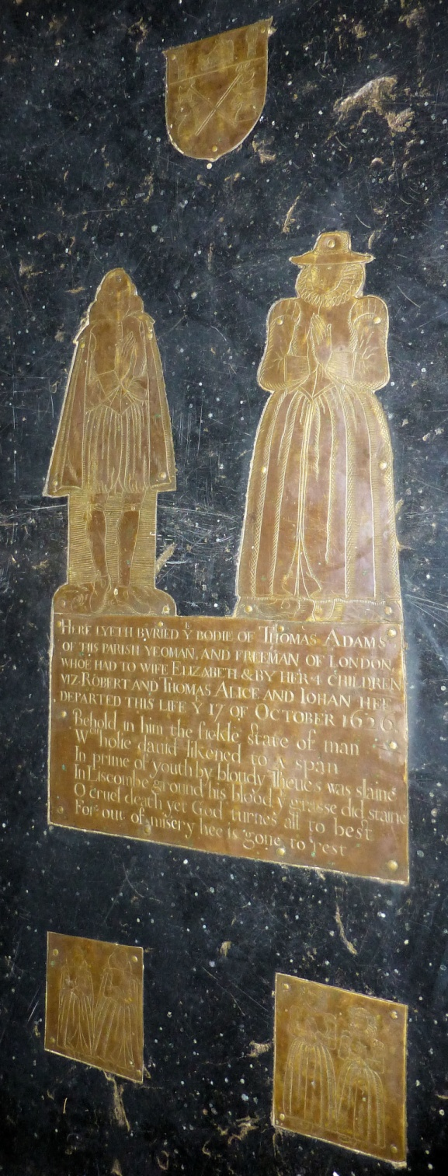

Thomas Adams is on the left in this oblique view.

Figures representing their four children; two boys on the left and two girls on the right. All have faces similar to Thomas.

Butchers Livery Company of London - Coat of Arms.

Elizabeth is on the right.

Inscription and poem commemoration.

“Behold in him the fickle state of man

Wch holie David likened to a span

In prime of youth by bloudy Thieves was slaine

In Liscombe ground his blood ye grasse did staine

O cruel death yet God turns all to best

For out of misery hee is gone to rest”

What was stolen from Thomas and how he died is not clear, but here was the joint Lord of the Manor of Swanbourne, a squire of stature who owned impressive property and lands – a Freeman of the City of London and Member of the Butchers’ Livery Company with business interests in the City. Did he have a lot of money on him? Almost certainly he did. Money, connected with his business interests or perhaps even to pay employee’s wages. Was the Saturday journey to London a regular one that Highwaymen might plan for? Certainly the grave inscription implies a great blood loss, which could be from flintlock pistol, sword or dagger, or a combination. He would probably be travelling on a horse drawn trap or carriage, as goods could be carried better, but riding by horseback is also possible.

The likely highway robbery scene at Liscomb, Soulbury on Saturday 17th October, 1626

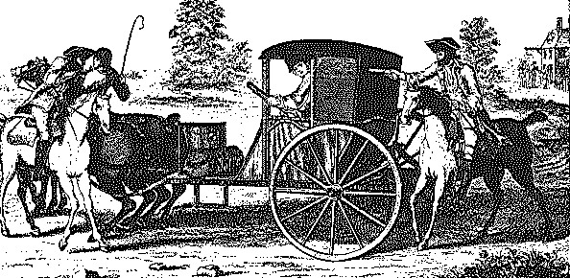

It would appear that the Highwaymen escaped. In Jacobean England, it was the job of the local Petty Constable to arrest criminals, aided by the Vice Petty Constable. These would be local men of standing in the community who were unpaid. Indeed, Thomas’s brother John is recorded in Bucks Archives as being a Vice Petty Constable himself in the 1640’s. There would be no systematic method of hunting down well organised gangs of criminals such as these. There is no record to suggest that the murderers were ever caught.

The body of Thomas was returned to Swanbourne quite quickly, and a burial took place the following day in the Chancel of St Swithun’s Church on Sunday, 18th October, 1626. Subsequent to this, a fine brass monument was produced, most likely by a craftsman within the community that knew the family. Finely etched, there is an image of Thomas and his wife Elizabeth in their image, followed by the inscriptions and at the bottom there were stylised images of the four children, all of whom are given similar facial features to Thomas. At the very top of the brass monument is the emblem of the Butchers’ Livery Company of London.

Analysis of the digitally enhanced images of Thomas and Elizabeth Adams

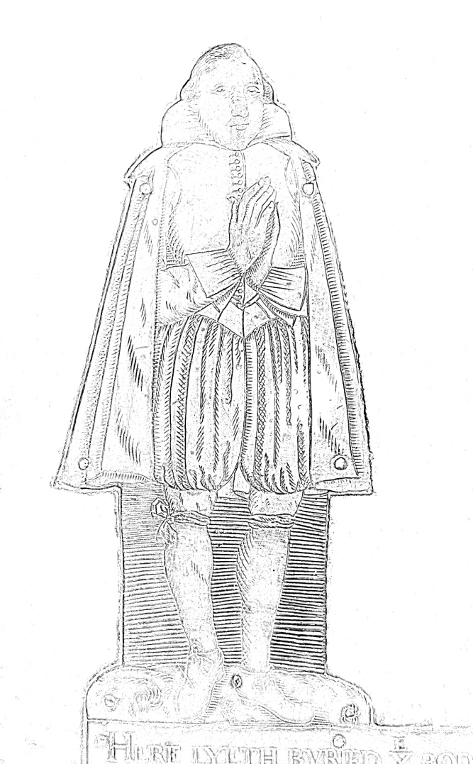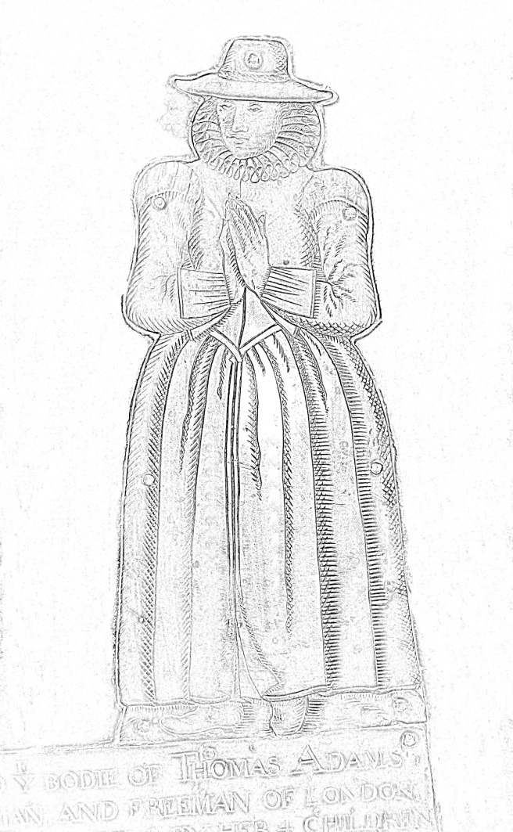

Note the tears on the left hand side of Elizabeth’s face.

Ladies Hat

Knee ribbons hold up lower leg garments

Heavy, thick cloak

Thomas is wearing a stiff tunic rather than a breast plate, as there is a line of buttons.

Elizabeth is wearing an expensive Jacobean dress

According to the legend, and this is the story repeated on current ‘ghost’ websites, Thomas’s widow Elizabeth never really recovered from the shock of hearing of her beloved husband’s death. She was devoted to her four children but was devastated. The joy had gone from her life. Two of their children (Johanne and Alice) who were just babies at the time of the murder, appear to have died in the subsequent months. Every evening she would be seen walking towards the Church to pay her respects at the tomb of her husband.   
  
The story goes that gradually Elizabeth faded away. As her children grew older, she seemed to lose the will to live. Finally, she slipped away quietly in her sleep. Elizabeth’s body was brought to St Swithin’s to rest in their vaults in the Church chancel (alongside her husband) which is where they both lie today.

Their Ghosts

These sightings have been concentrated in the buildings and area surrounding the Church made of Portland Stone; the Manor House (which for many years was an Old People’s Home and is now occupied by Swanbourne House School), the Church grounds themselves and surrounding paths and up to the Stone House (today known as Deverell’s Farm).

Following the death of Elizabeth, the Green Lady is said to have started haunting the village and those who encountered her identified the ghost as being the widowed Elizabeth Adams. Her ghost began to be seen following the route she had taken every evening in life, from the Manor house, across the road to the Church and in to the Church, and sometimes in the opposite direction, from the Church back to the Manor House. Over the years she has repeatedly been sighted. But this is not the only ghost story. There have been stories of a man with a black cape and hat (which could be Thomas) by people who have worked and lived in the Manor House. There are also stories of a child woken in the night with lights seemingly circling the bed, as well as the distant sound of piano playing coming from building lofts.

A letter from Ruth Thrower, previously

a carer at the Old People’s home at the

Manor House in the 1960’s and 1970’s

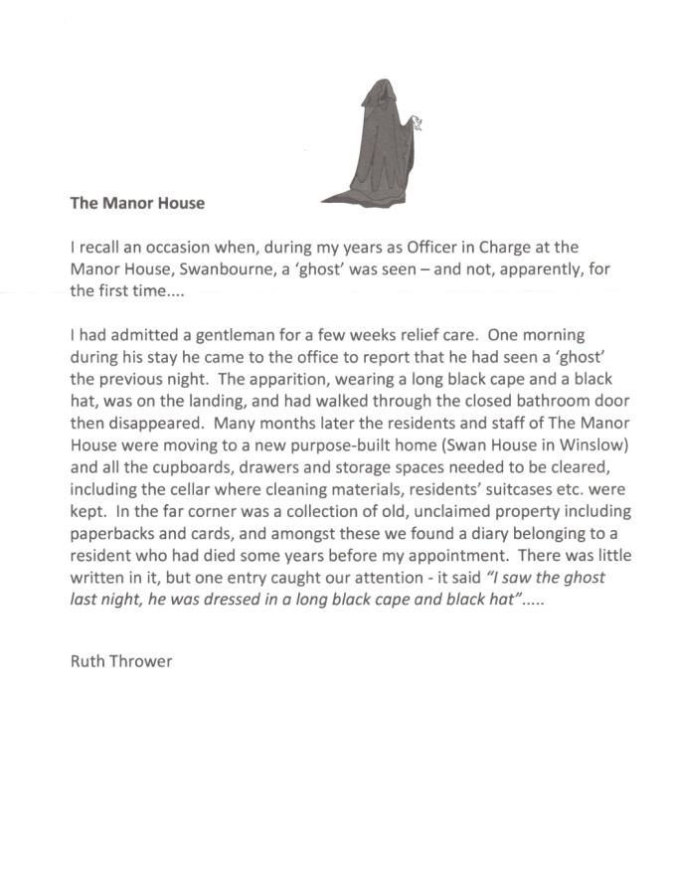(Recalled in January, 2013)

In investigating this story, the factual basis has been examined, and the alternative explanations seem to be more likely. A detailed examination of the Adams family tree has cast new light on the accuracy of the legend, as evidence from family wills show that Elizabeth had re-married within two years of the murder to Thomas Askew, subsequently having four more children and living at the Manor house throughout. Eventually, Josias Askew becomes prior Lord of the Manor. He is the grandson of Elizabeth Adams and Thomas Askew. However, Luton Paranormal Society have conducted field investigations and published a report (which is available through their website) supporting ghost theories.

1891 MAP OF SWANBOUNE

Areas (according to legend and reports) with the most ghost sightings and noises

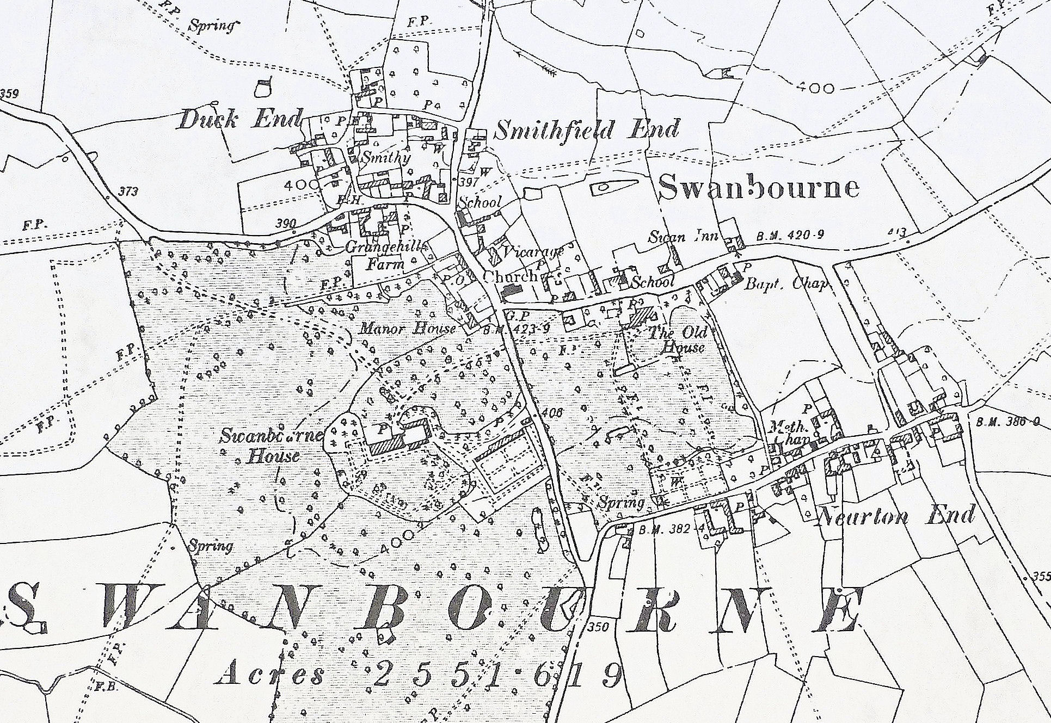

Logical and Scientific Explanations

**The Adams, Lords of Swanbourne, died out but could the Adams family still haunt the village?**

Being next to a pub for many years would certainly encourage ghost stories which in turn would encourage hallucinations and dreams. When the Manor was a home for the elderly, stories would have emerged again. Elderly people are subject to a greater range of serious illnesses which may be accompanied by hallucinations. The tendency during winter evenings for mist to hang on the hill top due to a local microclimate effect could, at times, give the appearance of ghostly movement if accompanied by a slight wind. This is an effect that I have observed myself during the winter.

*The path taken by the Green Lady Ghost is from the Manor House gates on the right to the Church on the left.*

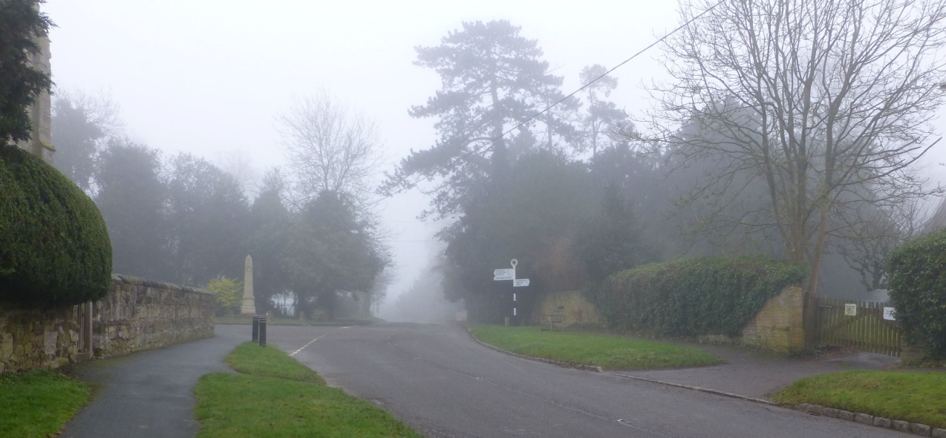

*Temperature Inversion explained*

[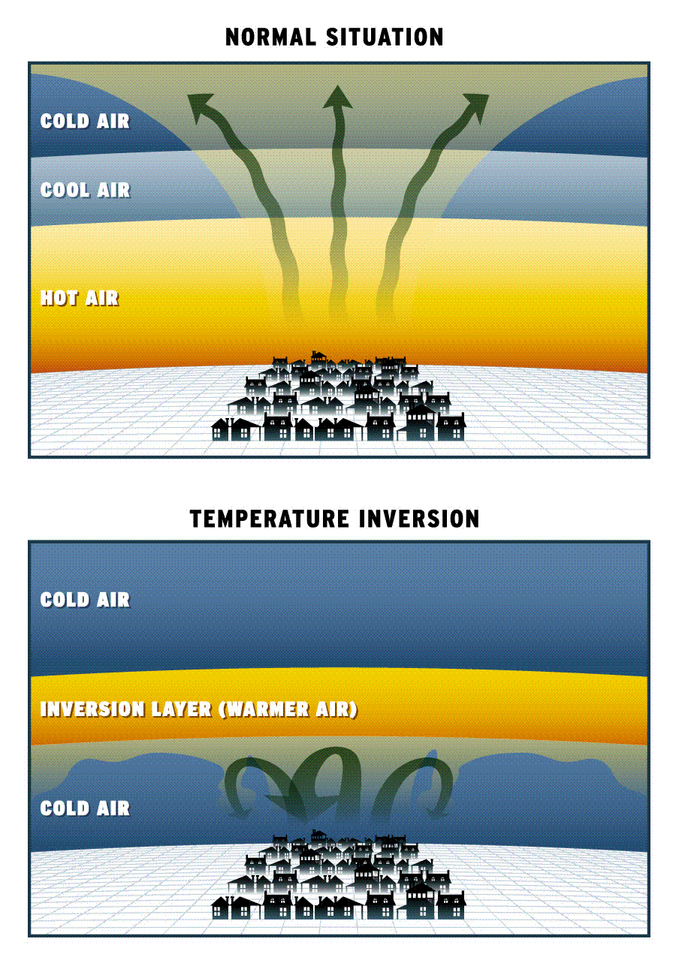](http://www.google.co.uk/url?sa=i&rct=j&q=how+temperature+inversion+works&source=images&cd=&cad=rja&docid=sXlxVn8C_UVDaM&tbnid=m-EPmXVx-bUZvM:&ved=0CAUQjRw&url=http://geographygems.blogspot.com/2011_09_01_archive.html&ei=hnYXUbzNO-aX0QX45oHICw&bvm=bv.42080656,d.d2k&psig=AFQjCNFILYio-z5IgSZU4xZ33xi_XSvIdg&ust=1360578502687606)

Normally the air temperature reduces as you go up.

When temperature inversion occurs, a warm layer of air traps cold air as it radiates off the ground resulting in condensation where warm and cold air meet. An evening mist or fog forms.

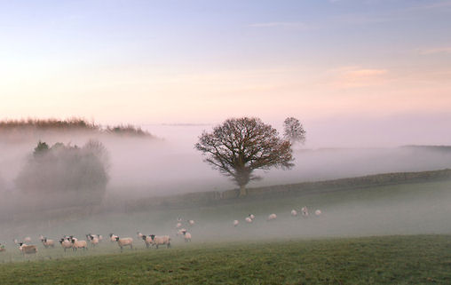

Evening hill fog from temperature inversion occasionally has a ghostly appearance.

Logical though these explanations seem, there are still some residents in Swanbourne who believe in other explanations. The case for two alternatives that have been suggested to me are summarised in the diagrams below.

Supernatural explanation

Pseudo-Scientific Explanation

Some rocks hold a record of the earth’s magnetic field thereby allowing the positions of the continents to be calculated, but this has only been proved in rocks already rich in iron minerals. So some rocks can record ancient events, but only at the time that the rock forms. The Portland Limestone does not contain much if any iron minerals. It is 99% calcium carbonate, so it would be difficult to persuade the scientific community that this type of suggestion would merit any serious investigation. In any case, the rocks had already formed 130 million years before. The quarry source for these rocks is almost certainly Whitchurch Hill.

Paranormal Investigations

A search on the Internet using a search engine such as GOOGLE, typing in the search something similar to ‘The Ghosts of Swanbourne’ will pick up some ghost and paranormal websites which tell the story of the ghosts of the village. In 2009 there was a field investigation by Luton Paranormal Society, the results of which are available via a PDF report from the following website:- <http://www.lutonparanormal.com/>

Power, wealth and the Adams Family

There are very few parts of the Parish of Swanbourne that have not at some point been in the ownership of the Adams Family, including:-

-The Manor House and 70 acres of land with Grange Farm (Home Farm) and hill (where Swanbourne House School is today)

- The White House (The Old House) and surrounding farmlands.

- Adams Farm (Athawes Farm) and at least 130 acres of farmland from Nearton End towards Hoggesdon.

- Charlton Hill Farm house and farmlands of 115 acres.

- Dodley Hill Farm with 200 acres.

- Moco Farm and farmlands crossing in to Little Horwood Parish, probably 100 acres.

- Little Horwood Rectory (building pulled down and replaced by Horwood House approx 100 years ago), and surrounding farmland in Little Horwood parish, probably greater than 100 acres.

- Above Mead Farm and farmlands between Shipton and Swanbourne, probably greater than 75 acres.

-Farmland and a house in Hoggeston, Bucks.

-Properties and land in Leicestershire and Northamptonshire, left to him after the death of his childless uncle John Adams in 1758 (will proved in 1760). James was the Executor to John’s will.

-A gentleman’s house in Middlesex, close to Richmond and the River Thames, where he would often reside.

In land terms, this was likely to be greater than 1000 acres in total, though not all of this was held at the same time.

John Adams, cousin of James, became seriously worried about the succession of the Adams wealth after his siblings had died of smallpox, as he could have no children himself. He specified in his will that in order to inherit his wealth (should James father a daughter), then her husband would be required to change his name to Adams. Alas, James also had no children.

The Wealth of the Adams Dynasty reached a peak during the 1770’s when James Adams also had business assets in London, as well as significant stock market investments. However, there were no direct heirs to their fortune, and the Adams surname from this stock died out with the death of James Adams in 1775.

Much of this wealth was given to individual friends or held as a complex trust, and three trustees were paid £50 each in advance in order to manage this. In today’s money that equates to £45,000 each. But he forgot his Stock Market shares. Many years after his death, the Bank of England gave notice in several newspapers that it would take over the unclaimed dividends and matured stock interests.

A significant amount of property ended up bequeathed to his two nieces descended from his wife’s sister, and then on to James Williamson his Great Nephew through his wife’s family. This included the property now known as the Old House and 5 acres of land which were sold to Thomas Fremantle in 1798. His son James Adams Williamson lived at Charlton Hill Farm.

BASED ON THE 1762 MAP OF SWANBOURNE North 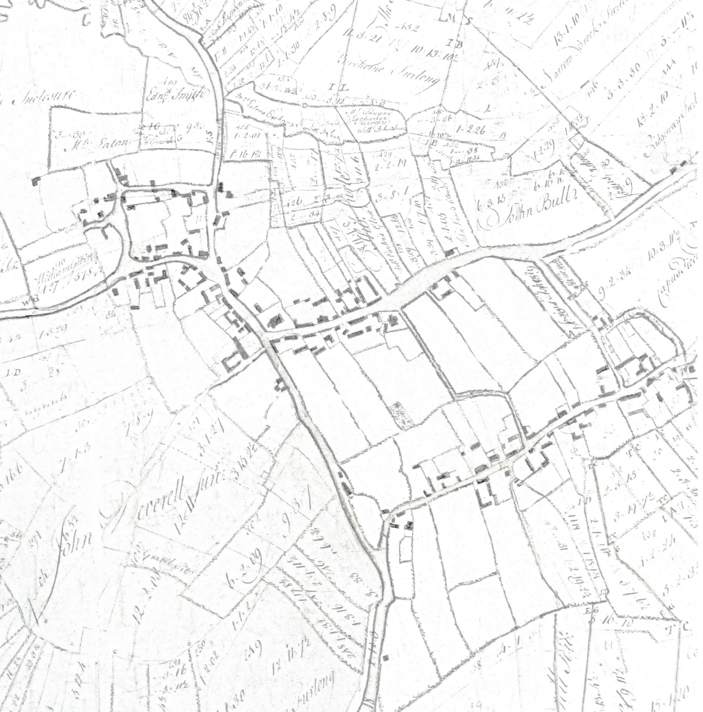

THOMAS ADAMS PURCHASES THE MANOR HOUSE FROM SIR JOHN FORTESCUE ‘S GRANDSON IN 1624, AND LIVES THERE WITH HIS WIFE (ELIZABETH) & 4 CHILDREN.

JOHN ADAMS MARRIED JOANNE WILLIAT IN 1614 FROM GT. HORWOOD, & LIVED IN THE WHITE HOUSE (NOW THE OLD HOUSE) FROM 1624 AFTER THE PURCHASE OF THE MANOR FROM SIR JOHN FORTESCUE’S GRANDSON (JOHN).

ROBERT & ALICE ADAMS LIVED AT ADAMS FARM (NOW CALLED ATHAWES FARM), NEARTON END, WITH THEIR 3 CHIDREN JOHN, THOMAS & AGNES. ROBERT DIED IN 1616.

NOTE:- AGNES ADAMS, SISTER OF THOMAS & JOHN MARRIED HUGH WILLIAT OF GT. HORWOOD IN 1609, AT SWANBOURNE CHURCH (BROTHER OF JOANNE WILLIAT, WIFE OF JOHN).

Elizabeth, wife of Thomas, lives in the Manor House until her death. John purchases the Rectory, Little Horwood and lives there. Josiah Askew acquires the Manor House and is joint lord with the Adams family until 1750

Elizabeth, wife of Thomas, lives in the Manor House until her death. John purchases the Rectory, Little Horwood and lives there. Josiah Askew acquires the Manor House and is joint lord with the Adams family until 1750

1626 Murder of Thomas

1750

1775

1798

1624

1678

1643

Sons John and Thomas purchase the joint Lordship of Swanbourne

John Deverill receives Josiah Askew’s half overlordship in Askew’s will, including the Manor House & land

James Adams, last male heir, dies. James’s will has the Old House placed in trust for female relatives until no longer needed.

A Robert Adams of Swanbourne is described as a “maimed soldier”

7 Large Houses fire damaged by Royalists in Civil War

**1600**

**1700**

**1800**

1600 Robert Adams and wife Alice Deverill live at Adams Farm with 3 children

Thomas Fremantle purchases the Old House, and 5 acres

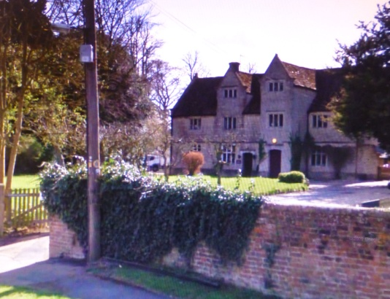

Robert Adams and wife Alice (Deverell) lived at Adams farm, Nearton End, with their three children: - Agnes, John and Thomas

*THE MANOR HOUSE with manorial rights and tithes was built around 1580 by Sir John Fortescue as his country retreat from Salden. Purchased and lived in by Thomas Adams, wife Elizabeth and their children in 1624*.

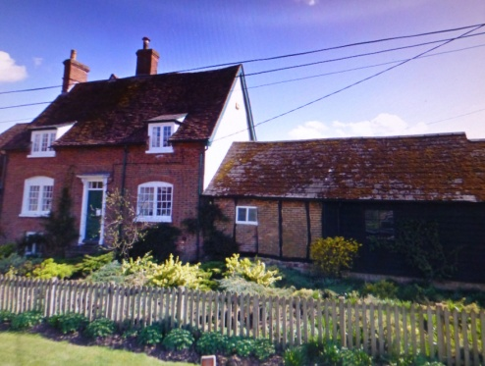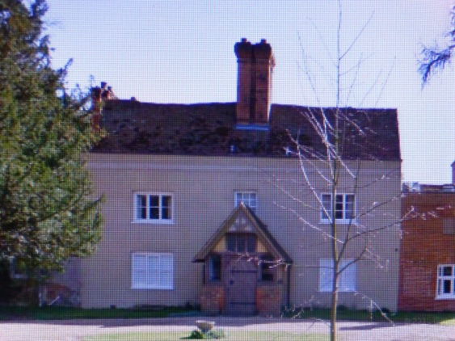

*THE WHITE HOUSE (NOW THE OLD HOUSE) with manorial rights and tithes was purchased by John Adams in 1624. He lived here with his wife Joanne (Willett) and their daughters.*

*ADAMS FARM (NOW ATHAWES FARM).*

*Built on the land of a former leprous nunnery granted to Theophilis Adams in late 16th Century by Queen Elizabeth1.*

**Order of Lords of the Manor (with tithes) of Swanbourne**

FORTESCUE FAMILY - Sir John Fortescue is cousin of Queen Elizabeth 1. His grandson sells in 1624 to the Adams brothers.

ADAMS FAMILY - Already living in Swanbourne at Adams Farm, John & Thomas purchase joint overlordship, the Manor House, Swanbourne House (the Old House) and extensive lands in 1624.

ASKEW FAMILY - New evidence suggests that after the murder of Thomas Adams (1626), his wife Elizabeth marries an Askew, and their grandson Josias acquires half of the overlordship (the Manor House moiety) derived from Thomas.

DEVERILL FAMILY - Half of the overlordship and the Manor House is left to John Deverill in Josias Askew’s will, in 1750. Passes down to William Deverell. The Manor House stays with the Deverill name until 1814, when sold to Thomas Downey.

THOMAS DOWNEY – Half overlordship purchased from William Deverell. Owns the Manor House moiety for four years until his death. His executors selling to Rev. Richard Lowndes in 1818.

LOWNDES - Rev. Richard Lowndes purchases the moiety with the Manor House in 1818, selling it at auction to the Fremantle family in 1828.

WILLIAMSON FAMILY - James Adams, the last of the male Adams line dies in 1775 and leaves the Old House moiety ( half of the overlordship) in the hands of trustees for two nieces and the greater share to James Adams Williamson, the great nephew (via James Adam’s wife).

FARBOROUGH – Joseph Farborough, London investor, buys the Old House moiety from Williamsons in 1787.

FREMANTLE FAMILY - Purchase of the Old House and 5 acres from Joseph Farborough in 1798. At first, Farborough retained the tithes with the Above Mead Lands, but they were purchased by about 1820 by the Fremantles. However, there is evidence to suggest that some elements of vicarial tithes remained with the Williamsons until 1820. The purchase of the second moiety by Sir Thomas Fremantle from Richard Lowndes in 1828 reunites the Overlordship of Swanbourne for the first time since 1624.

Notes on some historic manorial property names

**OLDER NAME** The White House = Swanbourne House = The Old House **CURRENT NAME**

**OLDER NAME** The Manor House = Swanbourne Old People’s Home = Swanbourne House School Pre-Prep **CURRENT NAME**

**OLDER NAME** The Stone House = Deverill’s Farm **CURRENT NAME**

**OLDER NAME** Adam’s Farm = Athawes Farm **CURRENT NAME**

**OLDER NAME** Old Rectory, Lt. Horwood = Horwood House (built on the same site) **CURRENT NAME**

**OLDER NAME** Grange Hill Farm = Home Farm **CURRENT NAME**

**Sources of information and references used to deduce the Adams Family tree**

The main sources of information used to deduce the Adams family tree are as follows:-

The monuments in the church, particularly in the Chancil which also contain the burial vaults of several generations of the Adams family. The monument to Thomas who was murdered is especially valuable, with brass inscriptions and images of Thomas, wife Elizabeth and their four children. The wall mounted monuments give a considerable amount of detail.

Parish Records, now fully transcribed, give us dates of key events, namely baptisms, marriage banns and deaths, sometimes with extra information about an individual.

Previously published book and newspaper articles. Ken Reading’s book “A History of An Anglo-Saxon Town” proved to be a good starting point, but there were Victorian publications, especially by the historian Arthur Clear. He has a particularly good article in The Bucks Held of Saturday, 30th November, 1895, but there are several other article of his as well as a book on the History of Bucks. There is also “Lismbe’s Bucks”, which is quoted in Arthur Clear’s articles, as wll as ”Lyson’s History of Bucks”, published in 1806. From these publications, it is clear that some of the monuments that used to be in the church are now lost or unreadable.

Bucks County Archives (at the Study Centre) in Aylesbury give access to the Parish Records from neighbouring villages Wills and archive material linked to Swanbourne including old maps, land and property transactions and related material. The Fremantle Archive was also deposited here in 1967, which contains materials linked to the Fremantle Estate.